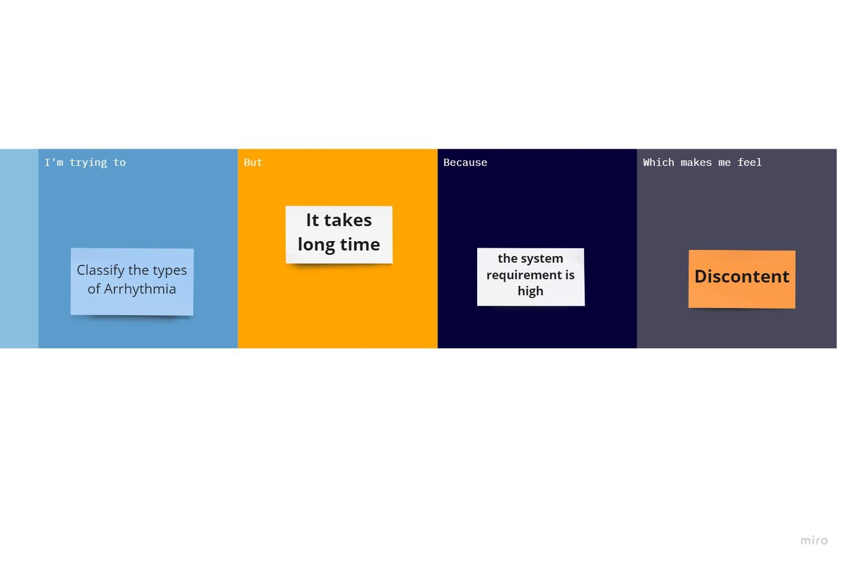

| **Problem statement (PS)** | **I am**  **(Customer)** | **I’m trying to** | **But** | **Because** | **Which makes me feel** |
| --- | --- | --- | --- | --- | --- |
| **PS-1** | **A Doctor** | **Find the types of arrhythmia** | **Complexity in QRS detection** | **of low patient data** | **Disappointed** |
| **PS-2** | **A Patient** | **Resolve the**  **potential complications** | **The prediction is incorrect sometime** | **of lack in quality of data** | **Worried** |